**Tugas Praktikum Konsep Pemrograman**

**Modul Praktikum 26 - 27 | Pointer 3 & 4**

Nama : Irvan Aditya Kurniawan

Kelas : 1 D4 IT B

NRP : 3124600044

**SOAL :**

**Untuk setiap program dibawah ini,**

* **Gambarkan Ilustrasi alokasi memori dari setiap baris pernyataan yang diproses**
* **Perkirakan hasil eksekusinya**

**Modul Praktikum 26 | Pointer 3**

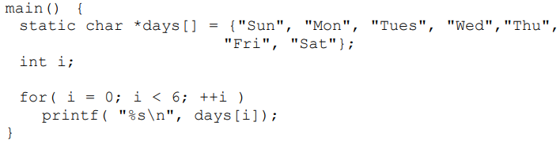

* **Illustrasi Alokasi :**

|  |  |  |
| --- | --- | --- |
| Variabel | Alamat | Value |
| *days[] | **0060FEF1** | **00x1** |
| **0060FEF2** | **00x5** |
| **0060FEF3** | **00x9** |
| **0060FEF4** | **00x14** |
| **0060FEF5** | **00x18** |
| **0060FEF6** | **00x22** |
| **0060FEF7** | **00x26** |
| i | **0060FEF8** | **0 1 2 3 4 5** |

* **Hasil Eksekusi :**

Sun

Mon

Tues

Wed

Thu

Fri

1. 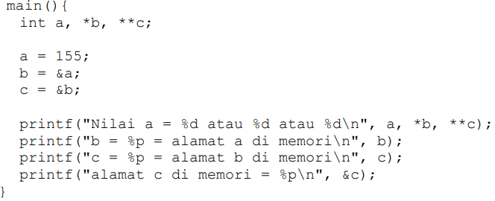

* **Illustrasi Alokasi :**

|  |  |  |
| --- | --- | --- |
| Variabel | Alamat | Value |
| a | **0060FEF1** | **155** |
| *b | **0060FEF2** | **0060FEF1** |
| **c | **0060FEF3** | **0060FEF2** |

* **Hasil Eksekusi :**

Nilai a = 155 atau 155 atau 155

b = 0060FEFC = alamat a di memori

c = 0060FEF8 = alamat b di memori

alamat c di memori = 0060FEF4

1. 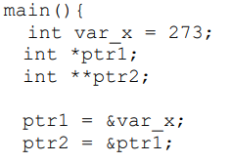

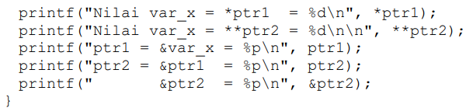

* **Illustrasi Alokasi :**

|  |  |  |
| --- | --- | --- |
| Variabel | Alamat | Value |
| var_x | **0060FEF1** | **273** |
| *ptr1 | **0060FEF2** | **0060FEF1** |
| **ptr2 | **0060FEF3** | **0060FEF2** |

* **Hasil Eksekusi :**

Nilai var_x = *ptr1 = 273

Nilai var_x = **ptr2 = 273

ptr1 = &var_x = 0060FEFC

ptr2 = &ptr1 = 0060FEF8

&ptr2 = 0060FEF4

1. 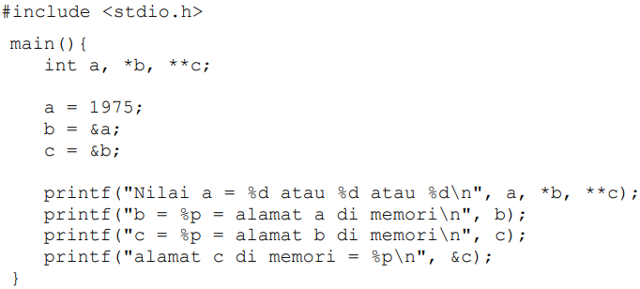

* **Illustrasi Alokasi :**

|  |  |  |
| --- | --- | --- |
| Variabel | Alamat | Value |
| a | **0060FEF1** | **1975** |
| *b | **0060FEF2** | **0060FEF1** |
| **c | **0060FEF3** | **0060FEF2** |

* **Hasil Eksekusi :**

Nilai a = 1975 atau 1975 atau 1975

b = 0060FEFC = alamat a di memori

c = 0060FEF8 = alamat b di memori

alamat c di memori = 0060FEF4

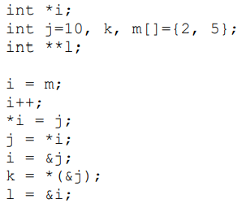

* **Illustrasi Alokasi :**

|  |  |  |
| --- | --- | --- |
| Variabel | Alamat | Value |
| *i | **0060FEF1** | **0060FEF4 0060FEF5** |
| j | **0060FEF2** | **10 10** |
| k | **0060FEF3** | **10** |
| m[0] | **0060FEF4** | **2** |
| m[1] | **0060FEF5** | **5 10** |
| **l | **0060FEF6** | **0060FEF1** |

* **Hasil Eksekusi :**

m[0] = 2, m[1] = 10

j = 10

k = 10

i = 0060FEF0

l = 0060FEF4

1. 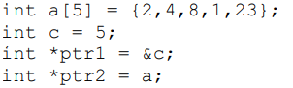Tentukan setiap statemen di bawah ini benar atau salah. Jika salah sertakan alasannya. Deklarasi :

|  |  |  |  |
| --- | --- | --- | --- |
| Statement | Benar | Salah | Alasan |
| a = c; |  | **X** | **Karena a adalah array dan b adalah variable sehingga a harus diberikan index untuk diubah dengan nilai c** |
| *c = 6; |  | **X** | **Karena jika simbol * digunakan untuk pointer sedangkan c adalah variable** |
| a[2] = c; | **X** |  |  |
| *ptr2 = c; | **X** |  |  |
| &ptr1 = c; |  | **X** | **Karena address tidak bisa diganti dengan nilai variable** |
| *(ptr2 + 1) = *(a + 3); | **X** |  |  |
| c = *(ptr2 + 1); | **X** |  |  |
| c = &ptr1; |  | **X** | **Karena tidak bisa memasukkan alamat ptr1 kedalam nilai variable c** |
| c = a[3] + 2; | **X** |  |  |
| *(ptr2 + 2) = *ptr1; | **X** |  |  |

**Modul Praktikum 27 | Pointer 4**

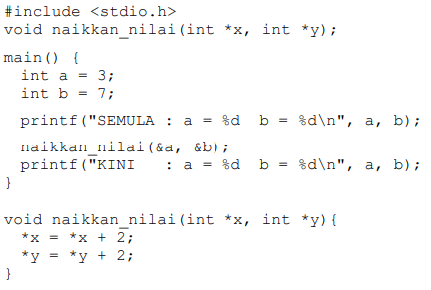



* **Illustrasi Alokasi :**

|  |  |  |
| --- | --- | --- |
| Variabel | Alamat | Value |
| a | **0060FEF1** | **3 5** |
| b | **0060FEF2** | **7 9** |
| *x | **0060FEF3** | **0060FEF1** |
| *y | **0060FEF4** | **0060FEF2** |

* **Hasil Eksekusi :**

SEMULA : a = 3 b = 7

KINI : a = 5 b = 9

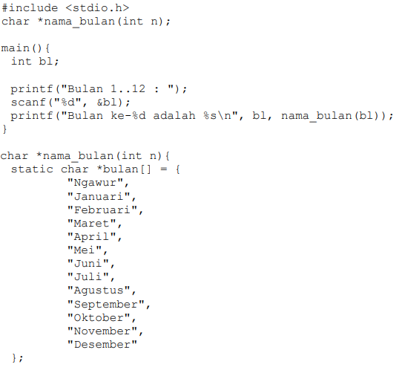





* **Illustrasi Alokasi :**

|  |  |  |
| --- | --- | --- |
| Variabel | Alamat | Value |
| *bulan[] | **0060FEF1** | **00x1** |
| **0060FEF2** | **00x8** |
| **0060FEF3** | **00x16** |
| **0060FEF4** | **00x25** |
| **0060FEF5** | **00x31** |
| **0060FEF6** | **00x37** |
| **0060FEF7 – 0060FEF13** | **00x41 – 00x87** |
| b1 | **0060FEF14** | **1** |
| n | **0060FEF14** | **1** |

* **Hasil Eksekusi :**

Bulan 1..12 : 1

Bulan ke-1 adalah Januari

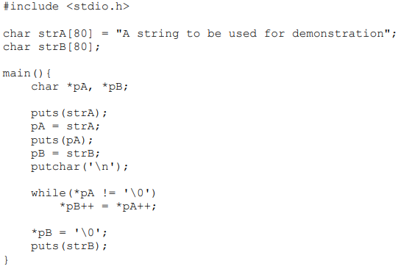



* **Illustrasi Alokasi :**

|  |  |  |
| --- | --- | --- |
| Variabel | Alamat | Value |
| strA | **0060FEF1** | **A** |
| **0060FEF2** |  |
| **0060FEF3** | **s** |
| **0060FEF4** | **t** |
| **0060FEF5** | **r** |
| **0060FEF6** | **i** |
| **0060FEF7 - 0060FEF38** |  |
| strB | **0060FEF81** | **A** |
| **0060FEF82** |  |
| **0060FEF83** | **s** |
| **0060FEF84** | **t** |
| **0060FEF85** | **r** |
| **0060FEF86** | **i** |
| **0060FEF87 - 0060FEF160** |  |
| *pA | **0060FEF161** | **0060FEF1 - 0060FEF38** |
| *pB | **0060FEF162** | **0060FEF81 - 0060FEF108** |

* **Hasil Eksekusi :**

A string to be used for demonstration

A string to be used for demonstration

A string to be used for demonstration

1. 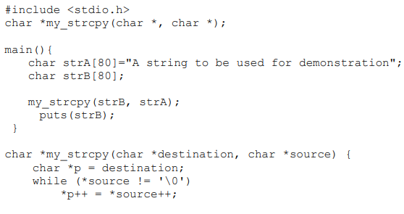

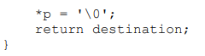

* **Illustrasi Alokasi :**

|  |  |  |
| --- | --- | --- |
| Variabel | Alamat | Value |
| strA | **0060FEF1** | **A** |
| **0060FEF2** |  |
| **0060FEF3** | **s** |
| **0060FEF4** | **t** |
| **0060FEF5** | **r** |
| **0060FEF6** | **i** |
| **0060FEF7 - 0060FEF80** |  |
| strB | **0060FEF81** | **A** |
| **0060FEF82** |  |
| **0060FEF83** | **s** |
| **0060FEF84** | **t** |
| **0060FEF85** | **r** |
| **0060FEF86** | **i** |
| **0060FEF87 - 0060FEF160** |  |
| *p | **0060FEF161** | **0060FEF1 - 0060FEF38** |
| *source | **0060FEF162** | **0060FEF81 - 0060FEF108** |
| *destination | **0060FEF163** | **0060FEF161** |

* **Hasil Eksekusi :**

A string to be used for demonstration

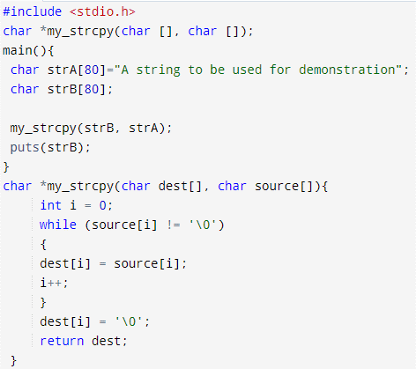



* **Illustrasi Alokasi :**

|  |  |  |
| --- | --- | --- |
| Variabel | Alamat | Value |
| strA | **0060FEF1** | **A** |
| **0060FEF2** |  |
| **0060FEF3** | **s** |
| **0060FEF4** | **t** |
| **0060FEF5** | **r** |
| **0060FEF6** | **i** |
| **0060FEF7 - 0060FEF80** |  |
| strB | **0060FEF81** | **A** |
| **0060FEF82** |  |
| **0060FEF83** | **s** |
| **0060FEF84** | **t** |
| **0060FEF85** | **r** |
| **0060FEF86** | **i** |
| **0060FEF87 - 0060FEF160** |  |
| dest[0] | **0060FEF161** | **A** |
| dest[1] | **0060FEF162** |  |
| dest[2] | **0060FEF163** | **s** |
| dest[3] | **0060FEF164** | **t** |
| dest[4] | **0060FEF165** | **r** |
| dest[5] | **0060FEF166** | **i** |
| dest[6] – dest [79] | **0060FEF167 - 0060FEF240** |  |
| source[0] | **0060FEF241** | **A** |
| source[1] | **0060FEF242** |  |
| source[2] | **0060FEF243** | **s** |
| source[3] | **0060FEF244** | **t** |
| source[4] | **0060FEF245** | **r** |
| source[5] | **0060FEF246** | **i** |
| source[6] – source[79] | **0060FEF247 - 0060FEF320** |  |
| i | **0060FEF321** | **0 1 2 3 4 5….. 37** |

* **Hasil Eksekusi :**

A string to be used for demonstration

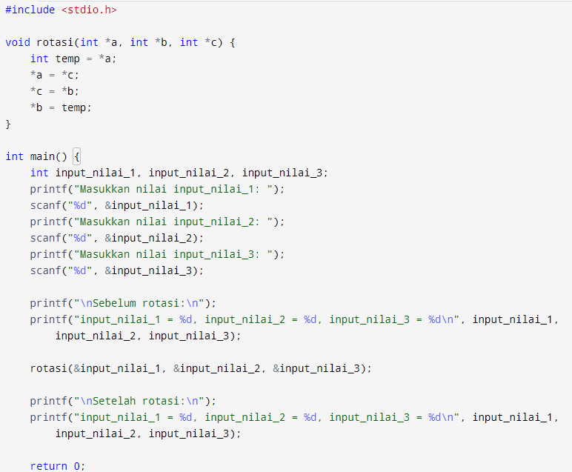



* **Hasil Eksekusi :**

